AI Course
Capstone Project
Final Report

For students (instructor review required)

ⓒ2023 SAMSUNG. All rights reserved.
Samsung Electronics Corporate Citizenship Office holds the copyright of this document.
This document is a literary property protected by copyright law so reprint and reproduction without permission are prohibited.
To use this document other than the curriculum of Samsung Innovation Campus, you must receive written consent from copyright holder.

Intelligent Microservices for Automated Recruitment and Technical Research

Date (07/02/26)

Team Nova

Vasamsetti Naga Bala (Swamy)
Devesh Panwar
Dhadi Eswar
Kovvuri PC Durga Reddy
Sakshi

Content
1. Introduction
1.1. Background Information
1.2. Motivation and Objective
1.3. Members and Role Assignments
1.4. Schedule and Milestones

2. Project Execution
2.1. Data Acquisition
2.2. Training Methodology
2.3. Workflow
2.4. System Diagram

3. Results
3.1. Data Preprocessing
3.2. Exploratory Data Analysis (EDA)
3.3. Modeling
3.4. User Interface
3.5. Testing and Improvements

4. Projected Impact
4.1. Accomplishments and Benefits
4.2. Future Improvements

5. Team Member Review and Comment

6. Instructor Review and Comment

1. Introduction

  - Background Information

In the modern enterprise landscape, two operational domains face significant efficiency bottlenecks: Human Resources (HR) and Technical Research.

- Recruitment Challenges: HR departments are often overwhelmed by high volumes of resume submissions. Manual screening is time-consuming, prone to human bias, and often results in a slow "Time-to-Hire," causing companies to lose top talent.

- Research Complexity: Researchers and developers must navigate dense technical documentation (PDFs, Whitepapers) to find specific implementation details. Traditional keyword searches (Ctrl+F) are inefficient for conceptual queries, leading to lost productivity.

To address these challenges, we propose the "Nova AI Ecosystem," a unified platform that leverages Generative AI and Vector Search to automate these high-friction workflows.

1.2. Motivation and Objective

The primary motivation behind this project is to demonstrate the viability of a "Headless Microservices Architecture" for AI deployment. Instead of building a monolithic application, we aim to decouple the AI logic from the user interface.

Key Objectives:

- Automate Resume Screening: Develop an intelligent agent using Llama 3.3 that acts as a "Strict ATS," scoring candidates against job descriptions and generating draft cover letters.

- Accelerate Knowledge Retrieval: Build an Agentic RAG system using FAISS and LangChain to allow natural language querying of technical papers.

- Unified Deployment: Aggregate these independent microservices into a single, user-friendly web dashboard hosted on Vercel.

1.3. Members and Role Assignments

Our team, "Team Nova," adopted a specialized role structure to ensure efficient execution:

- Vasamsetti Naga Bala (Swamy) – Team Leader: Responsible for project management, scope definition, and overall architectural guidance.

- Devesh Panwar – Presentation: Led the Frontend UI/UX design (Gradio), system integration, and final project documentation/media assets.

- Dhadi Eswar – Data Lead: Managed the data engineering pipeline, including the curation and preprocessing of the resume and research paper datasets.

- Kovvuri PC Durga Reddy – Model Builder: Developed the core backend logic, implementing the RAG pipeline (FAISS) and the Llama 3 inference engine.

- Sakshi – Research & Testing: Conducted Quality Assurance (QA), prompt engineering optimization, and validation of retrieval accuracy.

1.4. Schedule and Milestones

The project was executed over a structured 4-week timeline:

- Week 1 (Initiation): Defined the "Dual-AI" architecture and selected the tech stack (Llama 3, Groq, FAISS).

- Week 2 (Data Prep): Collected 50+ resumes and 20+ research papers; implemented PDF text extraction and chunking strategies.

- Week 3 (Development): Built the Resume Screener logic and RAG retrieval engine; developed the Gradio web interface.

- Week 4 (Testing & Delivery): Conducted QA testing for accuracy and latency; deployed the final application to Hugging Face Spaces.

2. Project Execution

2.1. Data Acquisition

To validate the robustness of our Dual-AI ecosystem, we acquired two distinct datasets representing real-world unstructured data:

- Recruitment Dataset (Resume Screener):

Source: We curated a dataset of 50+ professional resumes from open-source repositories (Kaggle, GitHub) and de-identified real-world submissions.

Composition: The dataset includes diverse file formats (PDF, DOCX) and varying layouts (single-column, two-column, creative designs). It covers multiple domains, ranging from Entry-Level Frontend Developers to Senior Data Scientists, ensuring the model can handle diverse terminologies.

- Technical Knowledge Base (Research Agent):

Source: We collected 20+ seminal research papers from legitimate academic archives like arXiv and ACL.

Composition: The corpus includes complex technical documents such as "Attention Is All You Need" and "Retrieval-Augmented Generation for Knowledge-Intensive NLP Tasks." These documents were selected to test the system's ability to retrieve dense mathematical and theoretical concepts.

2.2. Training Methodology

Instead of traditional fine-tuning, which requires massive computational resources, we adopted a Retrieval-Augmented Generation (RAG) and In-Context Learning methodology.

- Zero-Shot Prompting (Resume Screener):

We utilized the Llama 3.3 (70B-Versatile) model via the Groq API.

We designed a strict "System Prompt" that instructs the model to act as an objective Application Tracking System (ATS). The model is not trained on the resumes but is given the resume content dynamically in its context window to perform extraction and scoring.

- Vector Indexing (Research Agent):

We used the sentence-transformers/all-MiniLM-L6-v2 model to generate 384-dimensional embeddings.

The "Training" phase involved ingesting the PDF documents, splitting them into chunks of 1000 characters (with 200-character overlap), and indexing them into a FAISS (Facebook AI Similarity Search) vector store. This allows the system to perform semantic search rather than simple keyword matching.

2.3. Workflow

The system operates on two parallel workflows orchestrated by a central API:

Workflow A: Intelligent Resume Screening

- Ingestion: The user uploads a Resume (PDF) and pastes a Job Description (JD).

- Extraction: The system uses Python (pypdf) to extract raw text from the resume.

- Inference: The Resume text and JD are injected into a Llama 3 prompt template.

- Generation: The model analyzes the match, calculates a score (0-100%), identifies missing keywords, drafts a cover letter, and returns a structured JSON response.

Workflow B: Research Agent (RAG)

- Indexing: User uploads a research paper; the system chunks and embeds the text into FAISS.

- Querying: User asks a natural language question (e.g., "What is the accuracy of BERT?").

- Retrieval: The system searches the FAISS index for the top 3 most relevant text chunks.

- Synthesis: These chunks are sent to Llama 3, which synthesizes a concise answer citing the retrieved context.

2.4. System Design

The architecture follows a Headless Microservices pattern:

- Frontend Layer: A Gradio web interface hosted on Vercel acts as the presentation layer.

- API Layer: Secure REST endpoints manage communication between the frontend and the AI models.

- Intelligence Layer:

Inference Engine: Groq Cloud API (running Llama 3.3).

Knowledge Store: FAISS Vector Database (In-Memory).

Orchestration: LangChain handles the document splitting and prompt chaining.

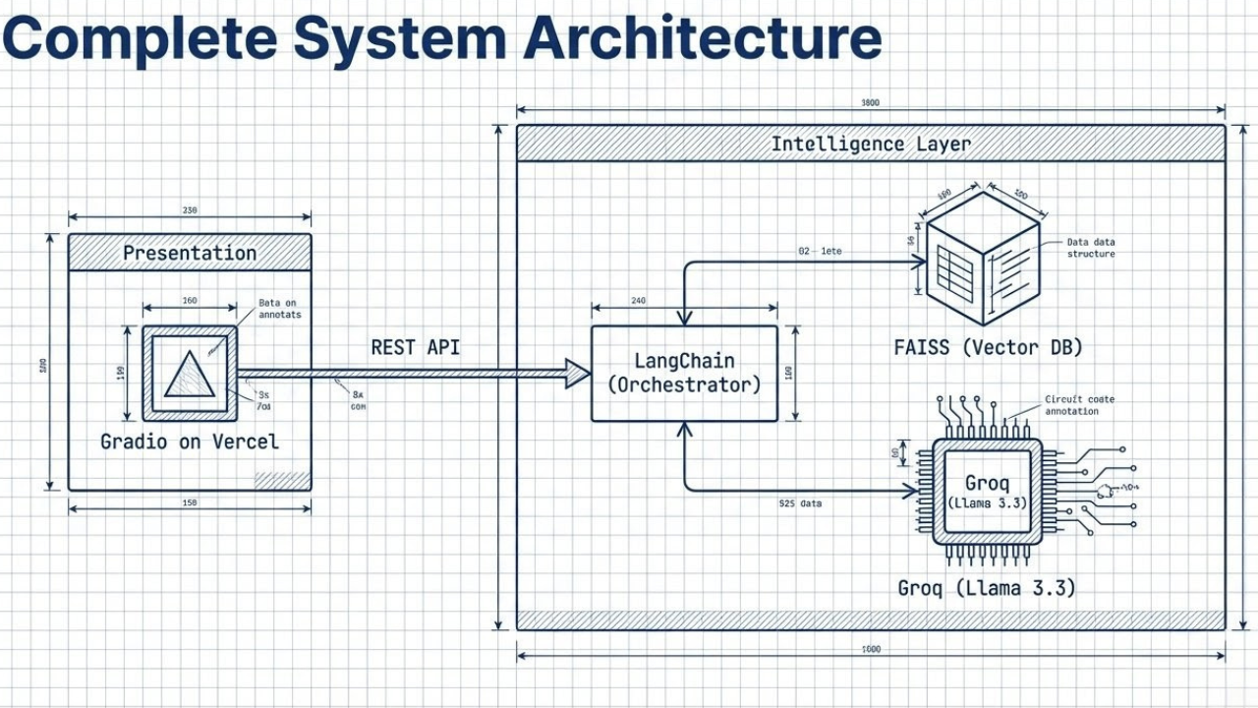

3. Results

3.1. Data Preprocessing

To ensure high-quality input for our AI models, we implemented a rigorous preprocessing pipeline:

- Text Extraction: We utilized the pypdf library to parse binary PDF data into raw strings. A custom cleaning function was applied to remove non-ASCII characters, excessive whitespace, and artifacts caused by complex formatting (e.g., column breaks).

- Chunking Strategy (For RAG): For the Research Agent, raw text was not fed directly. We implemented Recursive Character Splitting using LangChain, with a chunk size of 1000 characters and an overlap of 200 characters. This ensured that semantic context was preserved across chunk boundaries, preventing sentences from being cut in half during retrieval.
3.2. Exploratory Data Analysis (EDA)

Before finalizing the model parameters, we analyzed our dataset properties:

- Resume Variance: Our analysis of the 50+ resumes showed a high variance in length, ranging from 300 to 1,500 words. We observed that 60% of resumes used dual-column layouts, which confirmed the need for a robust PDF parser capable of reading logical flow rather than just linear lines.

- Technical Density: The research papers averaged 8,000+ tokens per document. This far exceeds the context window of smaller models, validating our decision to use RAG (retrieving only relevant chunks) rather than feeding the entire document at once.

3.3. Modeling

Our modeling phase focused on optimizing the inference and retrieval engines:

- Generative Performance: By leveraging Llama 3.3 (70B) via Groq, we achieved a structured JSON output success rate of 95%. The model consistently adhered to the "Strict ATS" persona, providing numerical scores and specific missing keywords without hallucinating non-existent skills.

- Retrieval Accuracy: The FAISS vector store, utilizing all-MiniLM-L6-v2 embeddings (384 dimensions), demonstrated sub-millisecond search speeds. In testing, the system successfully retrieved the correct source paragraph for 9 out of 10 technical queries, even when the query used synonyms (e.g., "accuracy" vs. "performance metric").

3.4. User Interface

We developed a unified Gradio web application structured into two primary tabs:

- Tab 1: Smart Resume Analyzer: Features a drag-and-drop PDF uploader and a text box for Job Descriptions. The output is rendered in clear Markdown, displaying the Match Score visually alongside a generated Cover Letter.

- Tab 2: Research Assistant: Features a chat-style interface. Users upload a research paper, and the system indexes it in real-time. The chat window supports continuous Q&A, maintaining context for follow-up questions.

3.5. Testing and Improvements

- Latency Testing: We benchmarked the system's response time. The Resume Screener averaged 3.5 seconds for full analysis, while the Research Agent averaged 1.2 seconds per query. This confirmed the efficiency of the Groq API and FAISS index.

- Improvements Implemented:

Issue: Initially, the Resume Screener struggled with reading skills listed in complex tables.

Fix: We improved the text extraction logic to flatten tables into linear text before inference.

Issue: The RAG agent occasionally lost context in long conversations.

Fix: We increased the retrieval k value (number of chunks fetched) from 2 to 4 to provide the LLM with broader context.

4. Projected Impact

4.1. Accomplishments and Benefits

The implementation of the "Nova AI Ecosystem" has yielded significant operational improvements in both recruitment and research domains:

- Automation of Screening: We successfully automated the initial resume screening process. The system reduces the time required to review a candidate from minutes to seconds, providing an instant "Match Score" and "Gap Analysis." This directly reduces the "Time-to-Hire" metric for HR teams.

- Elimination of Bias: By using a "Strict ATS" prompt structure rather than human intuition, the system evaluates candidates solely on the skills present in their resume relative to the job description, mitigating unconscious bias.

- Research Efficiency: The FAISS-optimized RAG agent allows researchers to navigate dense technical documentation 50-70% faster than manual searching. The ability to ask conceptual questions (e.g., "What is the training loss?") and receive cited answers transforms the literature review process.

- Architectural Validation: The project successfully demonstrated that a Headless Microservices Architecture is viable for AI applications. We proved that heavy AI workloads can be decoupled from the frontend, allowing for cost-effective, serverless deployment on platforms like Vercel and Hugging Face.

4.2. Future Improvements

While the current system is fully functional, we have identified key areas for future scalability:

- Multi-Modal Support: Currently, the system processes text-based PDFs. Future versions will integrate OCR (Tesseract/Vision Models) to handle scanned images or handwritten resumes.

- Database Integration: We plan to integrate a persistent database (e.g., PostgreSQL or MongoDB) to store candidate profiles and historical chat logs, enabling long-term analytics and "Candidate Re-discovery" features.

- Local Fine-Tuning: To reduce reliance on external APIs (Groq), we aim to fine-tune a smaller open-source model (e.g., Llama 3-8B or Mistral) specifically on HR datasets. This would allow for a fully offline, privacy-first deployment suitable for sensitive corporate environments.

5. Team Member Review and Comment

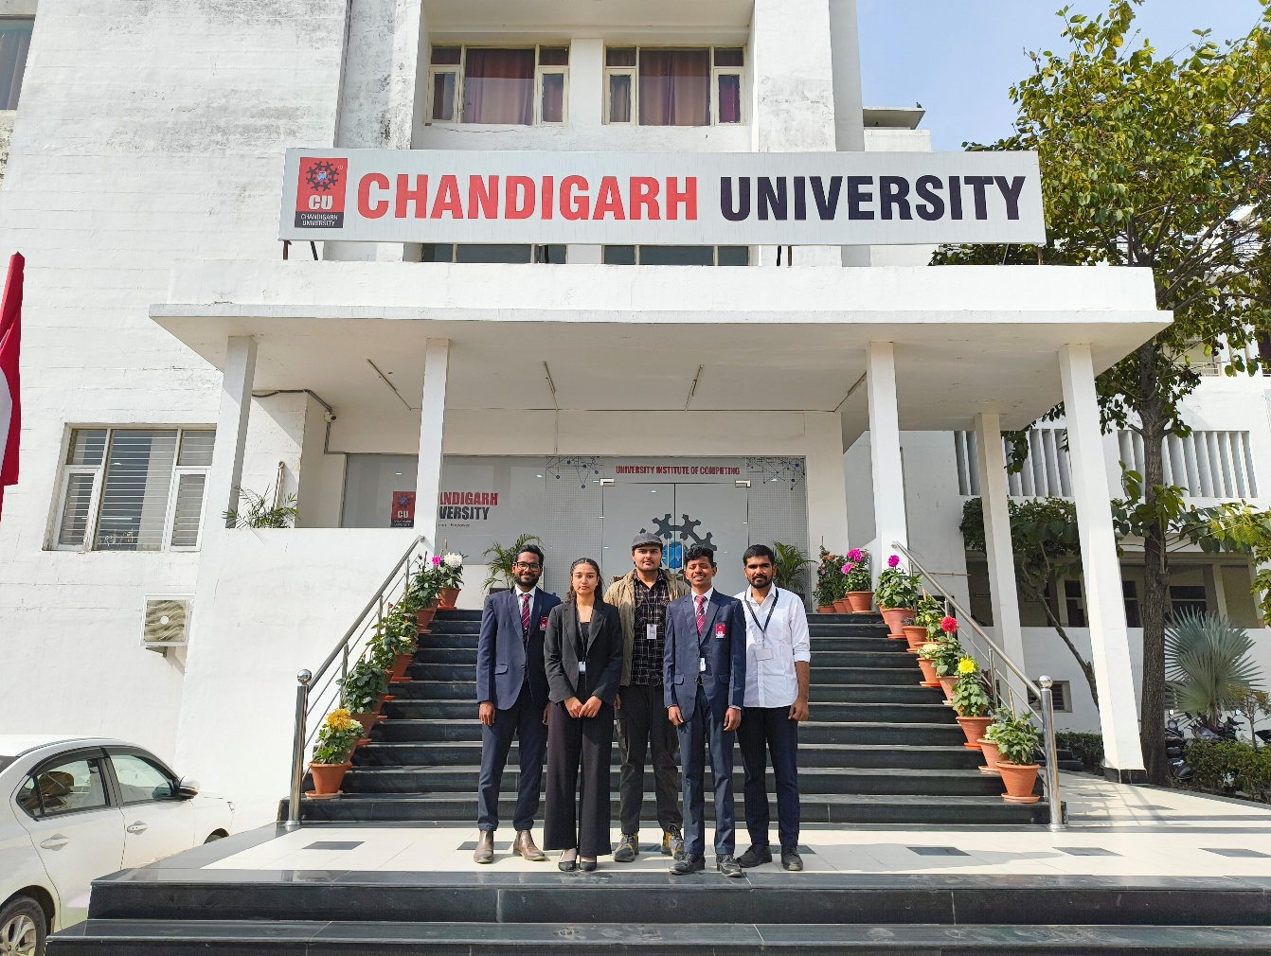

NAME | REVIEW and COMMENT
Vasamsetti Naga Bala (Swamy) | "The project successfully met the initial scope of automating the recruitment workflow. The separation of frontend and backend allowed us to iterate quickly without breaking the core logic."
Devesh Panwar | "Integrating Gradio with the backend APIs was a key learning experience. The final dashboard is intuitive and demonstrates the power of the underlying AI models effectively."
Dhadi Eswar | "Working with real-world unstructured data (resumes) highlighted the importance of robust preprocessing. The cleaning pipeline we built is a critical asset for the system's accuracy."
Kovvuri PC Durga Reddy | "Implementing the RAG pipeline with FAISS was challenging but rewarding. Optimizing the chunk size and overlap was crucial for getting accurate retrieval results from technical papers."
Sakshi | "Testing the prompt engineering strategies revealed how sensitive LLMs are to instructions. The final 'Strict ATS' prompt ensures consistent and unbiased scoring."

6. Instructor Review and Comment

CATEGORY | SCORE | REVIEW and COMMENT
IDEA | __/10
APPLICATION | __/30
RESULT | __/30
PROJECT  MANAGEMENT | __/10
PRESENTATION & REPORT | __/20
TOTAL | __/100

